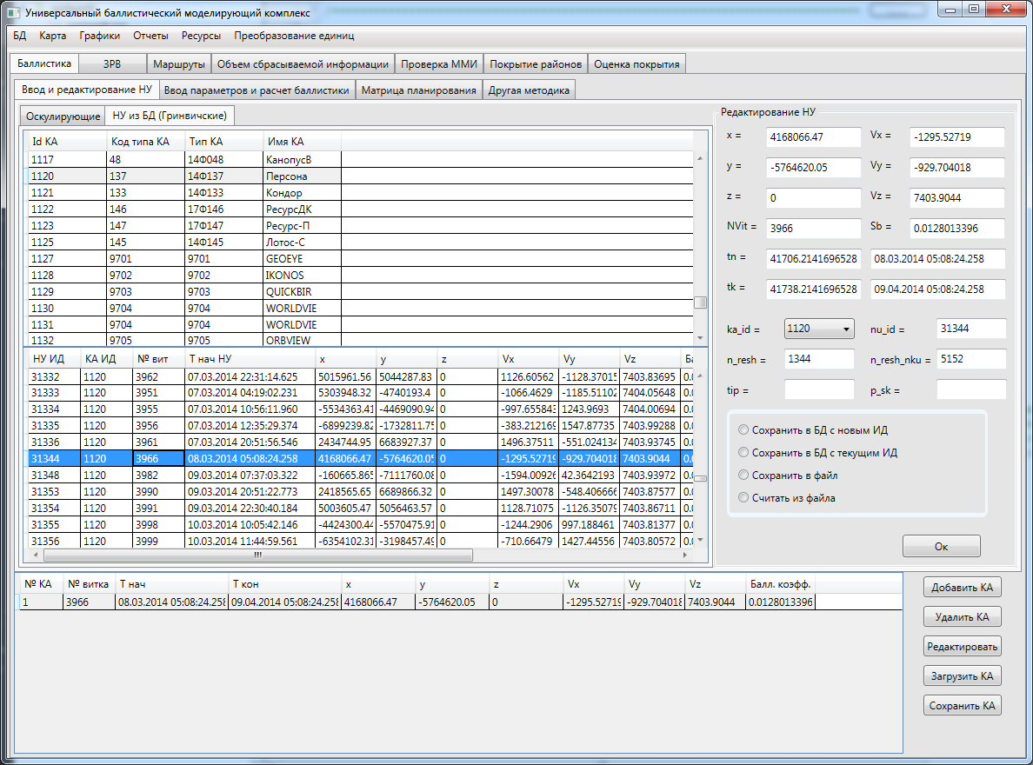

|  |  |  |  |  |  |  |  |  |  |  |
| --- | --- | --- | --- | --- | --- | --- | --- | --- | --- | --- |
| 1 | 3966 | 08.03.2014 05:08:24.258 | 09.04.2014 05:08:24.258 | 4168066.47 | -5764620.05 | 0 | -1295.52719 | -929.704018 | 7403.9044 | 0.0128013396 |

Ka_id 1120 **nu_id 31344** n_resh 1344 n_resh_nku 5152

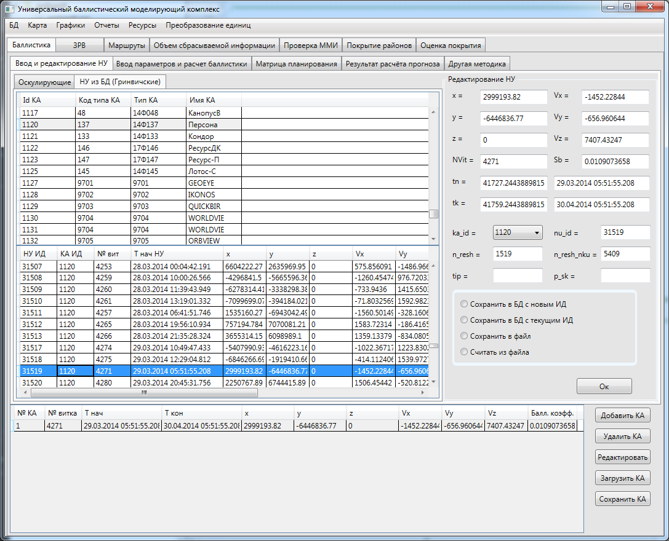

|  |  |  |  |  |  |  |  |  |  |  |
| --- | --- | --- | --- | --- | --- | --- | --- | --- | --- | --- |
| 1 | 4271 | 29.03.2014 05:51:55.208 | 30.04.2014 05:51:55.208 | 2999193.82 | -6446836.77 | 0 | -1452.22844 | -656.960644 | 7407.43247 | 0.0109073658 |

Ka_id 1120 **nu_id 31519** n_resh 1519 n_resh_nku 5409